MCQ’s

Q-1 What does DAX stands for?

1. Demand Analysis Expressions
2. Data and Expressions
3. Data Analysis Expressions
4. Datastructures & Algorithms Expressions

Q-2 Which of the following is not a DAX function?

1. Aggregation functions
2. Counting functions
3. Information functions
4. Window functions

Q-3 What does a Data-Source filter do?

1. Stops loading the data after a certain memory threshold
2. A parameter to filter data before loading into machines
3. Connects to the data source and refreshes the data within Power-Bi service, not affecting the local file
4. Connects to more databases/files

Q-4 Which of the following lets you receive value from user on live time?

1. Variables
2. Values
3. Parameters (inside power query>>manage parameters)
4. Return

Q-5 Which of the following does not use DAX?

1. Tableau
2. Power Pivot
3. Power BI
4. SSAS (SQL Server analysis Services)

Q-6 Which of the following will act as a ‘Filter’ in Visualizations?

1. Edit Interaction
2. Slicer
3. Bookmarks
4. Drill-Through

Q-7 What is X-velocity in Power Platforms?

1. Main Engine used in Power platforms
2. Main Database used in Power platforms
3. Main RAM of Power platforms

Q-8 Can we have Multiple Active Relationships in Power BI?

1. YES
2. NO

Q-9 What are Tiles?

1. A kind of a Visualization/Graphs
2. Grids in a Visualization/Graphs
3. Snap-shot of data pinned at Power BI Service
4. Actual Tiles (LOL)

Q-10 Which of the Following Language is used in Power Query Editor?

1. M-language
2. DAX
3. SQL
4. F# (read F sharp)

Q-11 Which of the following DAX functions can establish both one and bidirectional relationship between tables (like Many to Many)?

1. RELATEDTABLE
2. INTERSECT
3. RELATED
4. CROSSFILTER

Q-12 I want to choose a ‘filter’ to change all the graphs on a page. What should I choose ?

1. Report Level Filter
2. Page level Filter
3. Visual Level Filter
4. Slicer (Although it does the job, This is not a ‘filter’)

Q-13 For which task is PowerBi not recommended?

1. ETL (Extract,Transform,Load)
2. Data modelling and Relationships
3. Pulling Data/Web Scraping {Because we have other tools like Parse-hub,Python for web scraping and SQL for pulling huge amount of data}
4. Building Reports

Q-14 I want to see some top 10 kind of information/metric. What Visual do you use?

1. Pie Chart
2. Tree Map
3. Scatter Plot
4. Bar Chart

Q-15 What is a Z-Order in Power Bi?

1. To Calculate z-statistic/z-score of a data point to calculate it’s probability of occurrence
2. To sort Text data(like names in Descending Order)
3. Design Strategy to arrange visual over shapes

Q-16 Which of the following is not an IF-ELSE function?

1. If function
2. What-If
3. Switch function

Q-17 The answer of FORMAT(26-06-2020,"mmmm y") is-

1. Jul 2020
2. July 20
3. July 190
4. None of the above

Q-18 The answer of FORMAT( 234248.67, "Scientific") is-

1. 234248670%
2. 2,342,486.70
3. 234248(10-02)
4. 2.34E+05

Q-19 You want to show overall performance of your Organization(Take for example you have total sales and total cost columns) . Which Visual do you use?

1. KPI
2. Cards (Single/Multilevel)
3. Line chart

Q-20 What does Unpivoting option in Power Query do?

1. It takes the names from a column and makes a new column for each of name and the values of that column are an aggregation of another column (which we can choose).
2. It takes column names of several selected columns and transforms it into attribute-value pairs (2 columns), with attribute of that column being the column names and values being the aggregation.
3. Transposes the Data Table (Row <-> Columns)

Q-21 I have 2 columns Customer and Sales and want to calculate sum of sales for a customer named Amit. Which function do you use?

1. SUM
2. SUMMARIZE
3. SUMX
4. CALCULATE

Q-22 Which of these will not ignore logical values (like True(1),False(0)) in a column while calculating minimum?

1. MIN
2. MINA
3. MINX
4. MINL

Q-23 Which of these functions can calculate the maximum of 2 scalar expressions?

1. MAX
2. MAXA
3. MAXX
4. MAXIMUM

Q-24 I want to count the rows of a column after evaluating a expression which may contain Boolean (Booleans should be counted), Blanks . What do I use?

1. COUNT
2. COUNTX
3. COUNTAX
4. COUNTROWS

Q-25 Which of the following functions will work only on Azure SQL and DirectQuery Tables?

1. DISTINCTCOUNTNONBLANK
2. PRODUCTX
3. APPROXIMATEDDISTINCTCOUNT
4. NONE

Q-26 I want a table with one column of dates between StartDate and EndDate. What Function do I use?

1. CALENDARAUTO
2. CALENDAR
3. DATE
4. TIME

Q-27 Which of the following doesn’t return in Datetime Format?

1. TODAY
2. NOW
3. DATE
4. YEAR

Q-28 Which of the following functions will ignore all filters BUT does not return a table? (including both inside query and outside query filters)?

1. ALL
2. ALLEXCEPT
3. ALLCROSSFILTERED
4. ALLSELECTED

Q-29 Which will retrieve a value for present table from another table irrespective of whether that table is related or not.

1. LOOKUPVALUE
2. SELECTEDVALUE
3. KEYWORDMATCH
4. HASONEVALUE

Q-30 Which database can PowerBi not connect to?

1. AZURE
2. SALESFORCE
3. HADOOP
4. GOOGLE ANALYTICS

Q-31 What Cloud Architecture is Power BI Service?

1. HAAS
2. PAAS
3. SAAS
4. IAAS

Q-32 Where are Time Series Chart Located?

1. Filter Pane (where all filters,slicers are located)
2. Field Pane (where all visuals are located)
3. Get more Visuals (Appsource)

Q-33 Which Visual would you use to show Outliers?

1. Clustered Column Bar Chart
2. Scatter Plot
3. Tree Map
4. Line Chart

Q-34 What is Data Granularity?

1. Diamond Schema design is granular data
2. Data Granularity is the Filter direction between two visuals
3. It is level of detail presented in the data
4. It is Many-To-Many relationships

Q-35 Define Cardinality?

1. Types of Relationships between tables (ex- 1 to 1,1 to many,etc)
2. Number of Rows in data
3. Number of Columns in data
4. Direction of flow of data in a join between tables

Q-36 Which of the Following is best in terms of Space Complexity of Power BI?

1. Calculated column
2. Measure
3. Visual Table/Matrix

Q-37 Can DAX be used to modify the data in a table?

1. Yes
2. No (Dax Query can’t replace a table value but creates a new table to store these values)

For the Next 3 Questions Consider a Left Table (1/first) and a Right Table(2/second)

Q-38 ________ gives all from second ,matching from first.

1. Right Outer Join
2. Right Anti Join
3. Left Outer Join
4. Left Anti Join

Q-39 _________ gives only matching in both.

1. Full Outer join
2. Inner
3. Right Outer join
4. Left Outer join

Q-40 _________ gives only from second (excluding the first).

1. Left anti join
2. Right Anti join
3. Left outer join
4. Right Outer join

Q-41 __________ is a join not available in Power Query, but available in SQL.

1. Full Outer Join
2. Left Anti Join
3. Self-Join
4. Left Outer Join

Q-42 You are creating a measure which utilizes the column from another table. But the problem is the relationship is Inactive. What do you do?

1. RELATEDTABLE FUNCTION
2. LOOKUPVALUE FUNCTION
3. USERELATIONSHIP FUNCTION
4. Change the Active relationship in the Modelling tab manually /OR delete one relationship.

Q-43 Calculate a Measure for the sales for previous month, which one can you NOT use -

1. CALCULATE AND PREVIOUSMONTH
2. CALCULATE AND DATEADD
3. CALCULATE AND PARALLELPERIOD

Q-44 What can be achieved by removing unnecessary rows and columns?

1. IT is not necessary to remove unnecessary rows. Infact it’s good to keep all metadata intact
2. Deleting unnecessary rows can lead to damaging the structure of the data model
3. Deleting unnecessary rows and column not only reduces the data size and increases speed/performance of report but also it is a good practice to load only necessary data into your data model.

Q-45 Is it possible to create a relationship between two tables on two columns of different data types?

1. No, relationship is established on same data type columns only
2. Yes, if the direction of flow of data is set to Many-to-Many
3. Yes , but it is only available in paid versions of Power BI

Q-46 Which one leads to more Optimized performance?

1. Low Cardinality (means less distinct values in a column)
2. High Cardinality (means high unique values count)

Q-47 Which chart is useful to compare 2 values which are usually difficult to compare because of difference in scale?

1. BAR CHART
2. KPI VISUAL
3. COMBO CHART
4. GAUGE CHART

Q-48 ___________ dax function is used in dynamic security.

1. USERELATIONSHIP
2. USERPRINCIPALNAME
3. USERCULTURE

Q-49 You have 2 tables- A ‘USER’ table containing unique ID’s of Customers and ‘SALES’ table Consisting of their purchases,ID’s and unique id for each of their Purchases. What connection do you establish between the tables? (Direction is USER 🡪 SALES)

1. ONE TO ONE
2. ONE TO MANY
3. MANY TO ONE
4. MANY TO MANY

Q-50 Now you have the same USER table and a REGION table which has a column of 4 entries of region id from where the customers made orders. They(Tables) both have a common column RegionID. What connection do you establish now? (Direction is USER 🡪 REGION)

1. ONE TO ONE
2. ONE TO MANY
3. MANY TO ONE
4. MANY TO MANY

Q-51 DAX nested functions is equivalent to SQL what?

1. SQL CTE’s
2. SQL SUBQUERIES
3. SQL JOINS
4. SQL BUCKETIZATION

Q-52 What does CONTAINS(TABLE,[FIRST_NAME],’AMIT’,[LAST_NAME],’BOSE’) does? (FIRST_NAME,LAST_NAME are columns)

1. Returns Row index of Amit Bose in TABLE
2. Changes first_name column to AMIT and last_name column to ‘BOSE’
3. Return True/False whether the columns contains the respective values
4. None of the above

Q-53 What is the difference between CONTAINSSTRING (1) AND CONTAINSSTRINGEXACT (2)?

1. 1 is not CASE-sensitive whereas 2 is.
2. 1 is not ACCENT-sensitive whereas 2 is
3. Both 1 & 2

Q-54 A filter in Visual is an _______ filter and filters present in slicers/filter pane is an ______ filter.

1. Inner and Outer
2. Outer and Inner
3. None of the above

Q-55 Consider a SALES table with Q1&Q2 columns (Quarterly sales) , Country column, gender column ,consider the 2 queries-

TS = SUMX(ALL(SALES),SALES[Q1]+SALES[Q2]) 🡪 1

TS_ = SUMX(ALLSELECTED(SALES), SALES[Q1]+SALES[Q2]) 🡪 2

Now we build a visual (for ex-table/matrix) and put TS,TS_ and Country column inside the visual. Then we take a Slicer and put Gender in it’s field. Then,

1. TS&TS_ will contain total sales of respective countries and will also show total sales on the basis of gender if slicer is used.
2. TS will contain total sales as a whole and will show same value for every country. But will categorise on the basis of slicer. TS_ will also show same totalled sales for all country but will also be unaffected by slicer.
3. TS will contain total sales as a whole and will show same value for every country. It will also be unaffected by gender slicer. TS_ will also show same totalled sales for all country but will be affected by slicer.
4. None

Q-56 Consider a table Series with columns – Viewers(m) and Series_number –

Column =

var temp = Series[Viewers (m)]

RETURN

COUNTROWS(FILTER(ALL(Series),Series[Viewers (m)]>temp))+1

What is this Query doing?

1. Creating a column of number of viewers for each Series_number
2. Creating a ranking of every Series_number by Series[Viewers (m)]
3. Sorting the Series_number column itself by Viewers(m)
4. None of the above

Q-57 How many VARIABLES OR ‘var’ can you declare in a dax query?

1. Less than 3
2. Less than 4
3. Unlimited

Q-58 VARIABLE OR ‘VAR’ in dax is a –

1. DAX FUNCTION
2. DAX KEYWORD
3. DAX DATA-TYPE

Q-59 Is it possible to convert Data-Type using DAX? If yes, then what function can we use to convert for example Text to Integer?

1. YES, INT FUNCTION
2. YES, CONVERT FUNCTION
3. NO not possible

Q-60 What keyword is mandatory in a DAX Query ? (Query here refers to kind of queries we have in SQL. In previous questions we assumed queries to be simple dax expressions)

1. DEFINE
2. EVALUATE
3. ORDER BY
4. START AT

Q-61 If an author hides pages at the Power BI desktop level, are they visible in the power Bi service also(to the author) ? Are they also not visible in the Power BI desktop level , right after we hide them?

1. YES AND NO
2. NO AND YES
3. NO AND NO
4. YES AND YES

Q-62 Which one is True-

1. We need to import Custom visuals every time in a new report.
2. We don’t need to import them , they are already available under visualization pane
3. We need to import them just once, then they are available forever.

Q-63 Which one is the best defined workflow of Power BI?

1. Create report in Power BI Mobile 🡪 share in PBI Desktop 🡪 View/Interact in PBI Service
2. Create a report in PBI Service 🡪 share it in PBI Mobile 🡪 View/Interact in PBI Desktop
3. Create a report in PBI Mobile 🡪 share in PBI Desktop 🡪 View/Interact in PBI Service
4. Create a report in PBI Desktop 🡪 share in PBI Service 🡪 View/Interact in both PBI Service and PBI Mobile

Q-64 What is a collection of ready made visuals and pre-arranged in dashboards and reports is called?

1. An App
2. A canvas
3. A Tile
4. Scheduled Refresh

Q-65 Building blocks of Power Bi are-

1. Visuals, Dashboards, Reports, Tiles and datasets
2. Dashboard, Databases, Mobile Devices and Tiles
3. Power Query, Power Pivot and DAX
4. M language and DAX

Q-66 Which of the following filters are not available?

1. Tile level filter
2. Drillthrough
3. Report Level filter
4. Page Level Filter

Q-67 Is analyzing performance of each of your report elements possible in Power BI? Explain also?

1. YES, analyzing the metadata
2. YES, deleting unnecessary rows and columns in data, removing blanks and null/errors thus reducing the dataset size
3. YES, using the performance analyzer
4. NO, only way is to manually record Time taken to load and view reports

Q-68 How can we create a slide show like Power Point in Power Bi Report? (HINT: Use Bookmark)

1. No Bookmarks cannot be used as they are static
2. No Instead of a bookmark we can use a visual/custom visual
3. Yes We can use Buttons and set action to Bookmark
4. No We should use Power Point instead

Q-69 Output of ABS(-3.556) is-

1. -3.0
2. -4.0
3. -3.556
4. 3.556

Q-70 Output of CEILING(-10.3, -3) is-

1. -10
2. -9
3. -7
4. -13

Q-71 Which function does not give Variance?

1. VAR.P
2. VARX.P
3. VAR
4. VAR.S

Q-72 What does data alert do?

1. Alerts the user if the data limit exceeds a certain threshold.
2. Alerts the user that the data might be malicious.
3. Alerts the user if a certain data points aggregation/metric is above, below or at a certain threshold set by the user.
4. Alerts the user for a data refresh if there is a change in the data source.

Q-73 Data Alerts do not work in –

1. KPI
2. Gauge chart
3. Bar chart
4. Cards

Q-74 Data Alerts (as features) are only available in -

1. Power Bi Mobile
2. Power Bi Service
3. Power Bi Desktop
4. Power Bi Report Server

Q-75 Who can modify the data alert feature?

1. Dashboard owner
2. Everyone who has access to dashboard
3. Everyone who has access to dashboard and has Power Bi Premium.

Q-76 What does Q&A chart/visual in Power Bi do?

1. To take inputs from report(/dashboard) viewers and managers about the report.
2. To ask Questions about the loaded data and convert them into visuals
3. To ask Power Bi’s Artificial Intelligence about various features/options

Q-77 Define Dashboard?

1. A Canvas of report elements built in PBI desktop
2. A Canvas of report elements built in PBI Service
3. Dashboard is built by bringing together a couple of visuals/charts based on the loaded data
4. The Data Model tab

Q-78 Differentiate Reports and Dashboards?

1. Reports can have multiple pages, whereas in dashboards we have only one page.
2. They are same
3. Slicers and filters are not available in Reports whereas they are available in Dashboards
4. Reports are built in PBI Service whereas Dashboards are built in PBI Desktop

Q-79 Power Bi Paginated reports are created by-

1. Power BI Report Server
2. Power BI Service
3. Power BI Desktop
4. Power BI Report Builder

Q-80 What is a Workspace in Power BI?

1. Creates a bundle of Dashboards, Reports and data
2. The only area in PBI Service where we can edit a Report
3. Workspaces are places to collaborate with people/colleagues to create collections of dashboards, reports and paginated reports.

Q-81 You plan to join a fact table named ActivityLog to a Date dimension named ActivityDate. The date value in ActivityLog is a datetime column named ActivityStart.  
The date value in ActivityDate is a number column named DateID. DateID is in the ‘YYYYMMDD’ format.  
What should you do in the model before you create the relationship?

1) Change the Data Type of ActivityStart to Date.

2) Create a measure in ActivityLog that uses the FORMAT DAX function.

3) Change the Data Type of DateID to Date.

4) Create a calculated column in ActivityLog that uses the FORMAT DAX function.

Q-82 Can we perform a join between tables ,taking a column from one table and measure from another?

1. Yes
2. No

Q-82

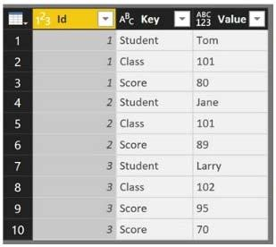

After Pivoting,

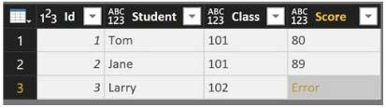

Resolve the error while also preserving all the data.

1. Change Data Type of the Value column
2. Select the Key column, and then click Remove Duplicates
3. Change the Aggregate Value Function of the pivot
4. Select the Score column, and then click Remove Errors

Q-83 You have following data

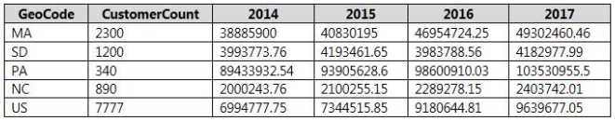

And want to change this to

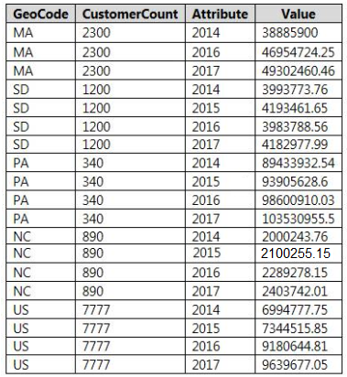

What do you do?

1. Transpose the data table
2. Reverse Rows of the data
3. Choose columns 2014 – 2017 and pivot them
4. Choose columns Geocode and CustomerCount and unpivot all the others

Q-84 You have two Microsoft SQL Server database servers named SQLProd and SQLDev. SQLDev contains the same tables as SQLProd, but only a subset of the data in SQLProd.  
You create a new Power BI Desktop model that uses 120 tables from SQLDev.  
You plan to publish the Power BI file to the Power BI service.  
You need to connect the model to the tables in SQLProd. The solution must minimize administrative effort.  
What should you do from Query Editor before you publish the model?

1. Create a new connection to SQLProd, and then import the tables from SQLProd.
2. Delete the existing queries, and then add new data sources.
3. Configure the Data source settings.
4. Edit the source of each table query

Q-85 You have the following table—

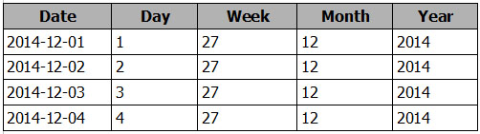

You need to add a column to display the date in the format of December 01, 2014.  
Which DAX formula should you use in Power BI Desktop?

1) FORMAT([Date], "MMM") & " " & FORMAT([Date], "DD") & ", " & FORMAT([Date], "YYYY")

2) FORMAT([Date], "M") & " " & FORMAT([Date], "D") & ", " & [Date].[Year])

3) [Date].[Month] & " " & FORMAT([Date], "D") & ", " & [Date].[Year])

4) FORMAT([Date], "MMMM DD, YYYY")

Q-86 You have a data table. You discover that a column named ErrorCode has several values starting with a space character, and a column named SubStatus contains several non-printable characters.  
You need to remove all the leading whitespaces from ErrorCode and all the non-printable characters from SubStatus. All other data must be retained.  
What should you do on each column?

1. ErrorCode – Extract🡪first characters then in SubStatus Extract🡪first characters
2. ErrorCode – Extract🡪length then in SubStatus Format🡪Clean
3. ErrorCode – Format🡪Clean then in SubStatus Format🡪Trim
4. ErrorCode – Format🡪Trim then in SubStatus Format🡪Clean

Q-87 You import a data like this

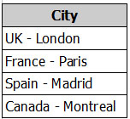

And now you want this

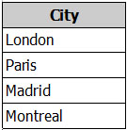

What do you do?

1. Format🡪Trim
2. Extract🡪Last Characters
3. Split Column🡪Delimiter
4. Extract🡪Text after Delimiter

Q-88 What can not be achieved by using the Power Bi service API?

1. Retrieve rows from a dataset
2. Add rows to a dataset
3. Create a dataset
4. Refresh an imported dataset

Q-89 Change this

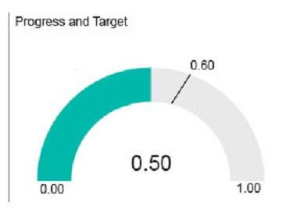

To this,

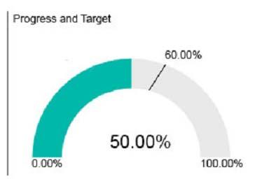

1. Create a calculated column that adds ‘%’ to the values
2. Create a calculated measure that adds ‘%’ to the values
3. Edit the query of data source and change the data type to percentage
4. From modelling tab change the data type to percentage.

Q-90 You are importing sales data from a Microsoft Excel file named Sales.xlsx into Power BI Desktop.  
You need to create a bar chart showing the total sales amount by region.  
When you create the bar chart, the regions appear as expected, but the sales amount value displays the count of sales amount instead of the sum of sales amount each region.

What do you do that data appears correctly?

1. Delete the query, import the data into Sql server, then import from it
2. Add a calculated column that totals the sales amount column
3. Change data-type of sales amount column to numeric
4. Try refreshing the data model /OR data source.

Q-91 Consider 3 tables Territory,Sales and Products.

Relationship is Territory 🡪 Sales (1 to Many) & Products 🡪 Sales(1 to Many). Will a slicer work from a column from Territory on a column from Products?

1. Yes
2. No

Q-92 State Why for the above question

1. Slicers don’t work in a 1 to Many relationship
2. Slicers only work when there is a direct relationship between two tables
3. If Connections made are one way (ex a🡪b) then a slicer won’t work the other way (ex b🡪a, like in the above case). We must make the connection bidirectional between Product and sales by Edit relationship🡪Cross filter direction🡪Set it to both and press OK.

Q-93 Choose the correct option? (Terminology alert: Many🡪1 means many side to one side)

1. Related when you need to access from 1🡪Many, Related-table when you need to access column from Many🡪1
2. Related when you need to access from Many🡪1, Related-table when you need to access column from 1🡪Many
3. Related when you need to access from Many🡪Many, Related-table when you need to access column from 1🡪Many
4. Related when you need to access from 1🡪1, Related-table when you need to access column from 1🡪Many

Q-94 Consider the query – ([Total_marks_of_Students] is a measure ,Gender is a column in Student table containing only ‘F’ & ‘M’)

CALCULATE(  
 CALCULATE([Total_marks_of_Students],Student[Gender]=’F’),Student[Gender]=’M’)

What does it return?

1. Total marks of students for M/male students
2. Total marks of students for F/Female students (As inner Query is given higher preference)

Q-95 You plan to use Power BI Embedded to deliver reports in a web application. You need to ensure that the reports display live data. Which data source you should use?

1. Microsoft Azure Data Lake Store
2. Microsoft Azure Table Storage
3. Microsoft Azure HDInsight
4. Microsoft Azure SQL Database

Q-96 You have a Power BI model that contains the following two tables: Sales(Sales_ID, sales_date, sales_amount, CustomerID) Customer(CustomerID, First_name, Last_name) There is a relationship between Sales and Customer. You need to create a measure to rank the customers based on their total sales amount. Which DAX formula should you use?

1. RANKX(ALL(Sales), SUMX(RELATEDTABLE(Customer), [Sales_amount]))
2. TOPN(ALL(customer), SUMX(RELATEDTABLE(Sales), [Sales_amount]))
3. RANKX(ALL(customer), SUMX(RELATEDTABLE(Sales), [Sales_amount]))
4. RANK.EQ(Sales[sales_amount], Customer[CustomerID])

Q-97 You embed a Power BI report in a Microsoft SharePoint Online page. A user name User1 can access the SharePoint Online page, but the Power BI web part displays the following error message: “This content isn’t available”. User1 is unable to view the report. You verify that you can access the SharePoint Online page and that the Power BI report displays as expected. You need to ensure that User1 can view the report form SharePoint Online. What should you do?

(NOTE: **Microsoft SharePoint Online** is a content management system that is part of the Office 365 suite of services. **SharePoint** provides a rich collaboration environment in which internal and external users can work together, manage content, and communicate information using a variety of **SharePoint** intranets and sites.)

1. Publish the app workspace.
2. Edit the settings of the Power BI web part.
3. Modify the members of the app workplace.
4. Share the dashboards in the app workspace.

Q-98 In the Power BI service, you create an app workplace that contains several dashboards. You need to provide a user named sudhanshu1@ineuron.com with the ability to edit and publish dashboards. What should you do?

1. Modify the members of the app workspace.
2. Configure security for the dataset used by the app.
3. Share the dashboard, and then modify the Access settings of the dashboard.
4. From the app workspace, click Update app, and then configure the Access settings.

Q-99 You have an app workspace named Retail Store Analysis in the Power Bl service. You need to manage the members that have access to the app workspace using the least amount of administrative effort. What should you do?

1. From the Power Bl Admin portal, click Usage metrics .
2. From the Office 365 Admin center, click Groups.
3. From the Office 365 Admin center, click Users.
4. From the Power Bl Admin portal, click Tenant settings.

Q-100 You plan to create a dashboard in the Power BI service that retrieves data from a Microsoft SQL Server database. The dashboard will be shared between the users in your organization. You need to ensure that the users will see the current data when they view the dashboard. How should you configure the connection to the data source?

1. Import the data by using the Import Data Connectivity mode.
2. Deploy an on-premises data gateway
3. Import the data by using the DirectQuery Data Connectivity mode.
4. Live Connection

Q-101 You created a KPI with a indicator and target variable

For the Trend axis you selected a months column. But you notice that the months are sorted by alphabetical order and not by datetime. What do you do?

1. Choose another visual
2. Remove the Trend Axis (remove the trend axis, sort by date and then reinsert it)
3. Modify visual level filters
4. Modify Drillthrough filters

Q-102 You created a stacked column chart visualization that displays ProductName by Date. You discover that the axis for the visualization displays all the individual dates. You need to ensure that the visualization displays ProductName by year and that you can drill down to see ProductName by week and day. What should you do first?

1. Configure a visual filter for the Date column that uses an advanced filter.
2. Create new columns for the date, year, week, and day.
3. Create a new hierarchy in the Sales table.
4. Format the virtualization and set the type of the X-Axis to Categorical.

Q-103 You plan to use Power BI Desktop to import 100 CSV files. The files contain data from different stores. The files have the same structure and are stored in a network share. You need to import the CSV files into one table. The solution must minimize administrative effort. What should you do?

1. Add a folder data source and use the Combine Files command.
2. Add a folder data source and use the Merge Queries command
3. Add a Microsoft Excel data source and use the Merge Queries command
4. Add text/CSV data sources and use the Append Queries command.

Q-104 Customer table-

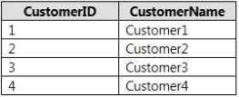

Order table-

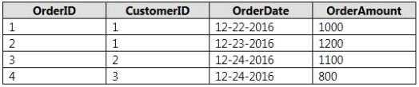

Desired result

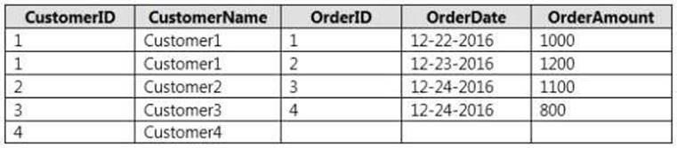

If you consider Customer table as first table, which join will you perform?

1. Union
2. Left Anti
3. Left Outer
4. Right Anti
5. Right Outer

Q-105 You plan to use Power BI Desktop optimized for Power BI Report Server to create a report. The report will be published to Power BI Report Server. You need to ensure that all the visualization in the report can be consumed by users. Which type of visualizations should you exclude from the report?

1. Funnel charts
2. Custom Visuals
3. R visuals
4. Bubble maps

Q-106 Consider this table

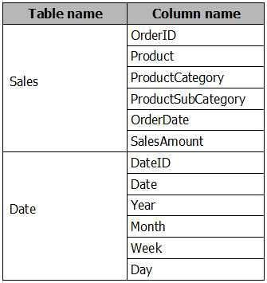

You plan to create a report to display TotalSales by ProductCategory and ProductSubCategory. Create a measure to calculate the % of TotalSales for each ProductCategory.

1. SUM([SalesAmount]) / CALCULATE(SUM[SalesAmount],FILTER(Sales,Sales[ProductCategory])) * 100
2. DIVIDE(SUM([SalesAmount]),CALCULATE(SUM([SalesAmount]), ALL(Sales[ProductCategory],Sales[ProductSubCategory])))
3. DIVIDE(SUM([SalesAmount]),CALCULATE(SUM([SalesAmount]), ALLSELECTED(Sales[ProductCategory],Sales[ProductSubCategory])))
4. DIVIDE(SUM([SalesAmount]),CALCULATE(SUM([SalesAmount]), ALLEXCEPT(Sales[ProductCategory],Sales[ProductSubCategory])))

Q-107 Consider the table—

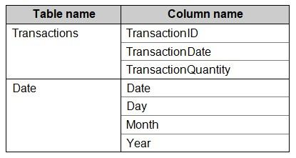

You need to create a measure to calculate a running total of TransactionQuantity.

1. SUMX(Transactions[TransactionQuantity],FILTER(Date[Date],Date[Date]<=MAX(Date[Date])))
2. CALCULATETABLE(SUM(Transactions[TransactionQuantity]),FILTER(ALL(Date[Date]),Date[Date]<=MAX(Date[Date])))
3. CALCULATE(SUM(Transactions[TransactionQuantity]),FILTER(ALL(Date[Date]),

Date[Date]<=MAX(Date[Date])))

1. None

Q-108 Now Calculate a running total of TransactionQuantity for every 30 days for the same table as above.

1. CALCULATE(SUM(Transactions[TransactionsQuantity]), DATESMTD(Date[Date]))
2. CALCULATE(SUM(Transactions[TransactionQuantity]),FILTER(ALL(Date[Date]),  
   Date[Date]>MAX(Date[Date])-30 && Date[Date]<=MAX(Date[Date]))
3. CALCULATE(SUM(Transactions[TransactionsQuantity]),PARALLELPERIOD(Date[Date],-1,Month))
4. CALCULATE(SUM(Transactions[TransactionQuantity]),FILTER(ALL(Date[Date]),  
   Date[Date]<MAX(Date[Date]) && Date[Date]>MAX(Date[Date])+30))

Q-109 You have the following two queries in Power BI Desktop:

A query named Query1 that retrieves a table named SMB_Customers from a Microsoft SQL Server database

A query named Query2 that retrieves a table named Enterprise_Customers from an Oracle database Both tables have the same columns. You need to combine the data from SMB_Customers and Enterprise_Customers. Which command should you use?

1. Combine files
2. Merge Columns
3. Merge Queries
4. Append Queries

Q-110 Consider this DATA MODEL—

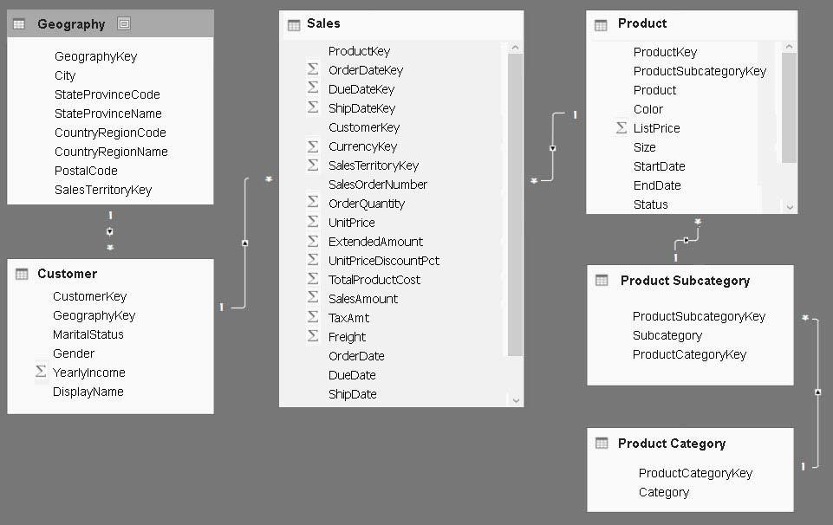

You need to add a measure to rank total sales (SalesAmount column) by product. The results must appear as shown in the following table—

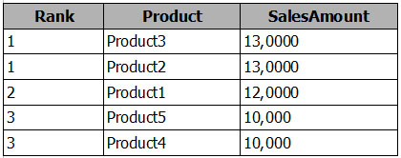

Which DAX will you use?

1. Product Ranking = RANKX(ALL('Product'), CALCULATE(SUM(Sales[SalesAmount])),,Asc, Dense)
2. Product Ranking = RANKX(ALL('Product'), SUM([SalesAmount]),,DESC, Skip)
3. Product Ranking = RANKX(ALL('Product'), CALCULATE(SUM(Sales[SalesAmount])),,DESC, Dense)
4. Product Ranking = RANKX(Product, [SalesAmount],,DESC, Skip)

Q-111 You have two tables named CustomerVisits and Date in a Power BI model. You create a measure to calculate the number of customer visits. You use the measure in the report shown below

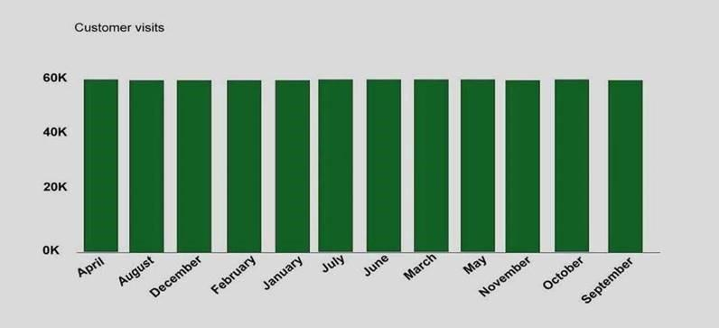

You discover that the total number of customer visits was 60,000, and that there were only 3,000 customer visits in April. You need to fix the report to display the correct data for each month. What should you do?

1. Create a relationship between the CustomerVisits table and the Date table.
2. Create a hierarchy in the Date table.
3. Modify the n=measure to use the CALCULATE DAX function.
4. Modify the measure to use the SUM DAX function.

Q-112 You have a query for a table named Sales. Sales has a column named CustomerID. The Data type of CustomerID is Whole Number. You refresh the data and find several errors. You discover that new entries in the Sales table contain nonnumeric values. You need to ensure that nonnumeric values in the CustomerID column are set to 0. Solution: From Query Editor, select the CustomerID column and click Remove Errors. Does this meet the goal?

1. Yes
2. No

Q-113 You have a Power BI report that displays a bar chart and a donut chart on the same page. The bar chart shows the total sales by year and the donut chart shows the total sale by category. You need to ensure that when you select a year on the bar chart, the donut remains unchanged. What should you do?

1. Set a visual level filter on the bar chart.
2. Edit the interactions form the Format menu.
3. Set a visual level filter on the donut chart.
4. Add a slicer to the page that uses the year column.

Q-114 You have a Power BI model for sales data. You create a measure to calculate the year-to-date sales. You need to compare the year-to-date sales with the previous year for the same time period. Which DAX function should you use?

1. LASTDATE
2. PREVIOUSYEAR
3. PARALLELPERIOD
4. SAMEPERIODLASTYEAR

Q-115 You have a query that retrieves sales data. A sample of the data is shown in the following table.

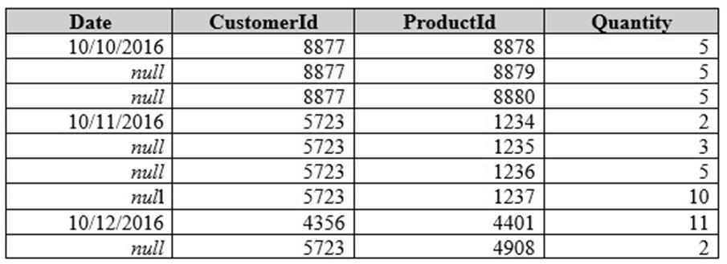

You need to ensure that the values in the Date column contain a date. Null values must be replaced with the date from the previous row. What should you click on the Transform tab in Query Editor?

1. Date, and then Earliest
2. Format, and then Clean
3. Fill, and then Down
4. Replace Values, and then Replace Errors

Q-116 You need to create a measure of Sales[SalesAmount] where Product[Color] is Red or Product[Size] is 50. Which DAX should you use?

1. CALCULATE(SUM([SalesAmount]), ALL(‘Product’[Color],’Product’[Size]))
2. CALCULATE(SUM([SalesAmount]), ‘Product’[Color]=”Red”||’Product’[Size]=50)
3. CALCULATE(SUM([SalesAmount]), FILTER(‘Product’,‘Product’[Color]=”Red”||’Product’[Size]=50))
4. CALCULATE(SUM([SalesAmount]), FILTER(‘Product’[Color]=”Red”||’Product’[Size]=50))

Q-117 Consider the data-model



You add another table named Territory to the model. A sample of the data is shown in the following table.

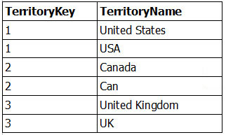

Which function should you use in the query for Territory before you create the relationship?

1. Distinct
2. IsDistinct
3. ReplaceMatchingRows
4. RemoveMatchingRows

Q-118 You enable Q&A on the dashboard. You need to provide users with sample questions that they can ask when using Q&A. Which settings should you modify from the Power BI Settings?

1. Dashboards
2. Subscriptions
3. Datasets
4. Workbooks

Q-119 You need to calculate the number of orders (Consider a OrderId column with distinct values only). What should you do?

1. Create a calculated measure that uses the COUNTA(Order_ID) DAX formula
2. Create a calculated measure that uses the SUM (Order_ID) DAX formula
3. Create a calculated column that uses the SUM (Order_ID) DAX formula
4. Create a calculated column that uses the COUNTA (Order_ID) DAX formula

Q-120 You plan to add a table named Date to the model. The table will have columns for the date, year, month, and end of the last month and will include data from January 1, 2013 to December 31, 2015.

Which DAX functions should you use to create the columns?

1. CALENDARAUTO, YEAR, MONTH, and EOMONTH
2. CALENDAR, YEAR, MONTH, and ENDOFMONTH
3. CALENDARAUTO, YEAR, MONTH, and ENDOFMONTH
4. CALENDAR, YEAR, MONTH, and EOMONTH

Q-121 A data analyst publishes several Power BI visualizations to a blog.  
You discover that some of the visualizations contain data that is considered private by your company.  
You need to prevent the visualizations from being published to the blog.  
What should you do?

1) From the Power BI Admin portal, disable the Publish to web setting.

2) From the Power BI settings, delete the embedded codes.

3) From the Power BI Admin portal, disable the Share content with external users setting.

4) From the dashboard settings, modify the Share dashboard settings

Q-122 You create a report in the Power BI service.  
You plan to provide external users with access to the report by publishing the report to a public blog.  
You need to ensure that the report in the blog post will be updated as the data is refreshed.  
What should you do in the Power BI service?

1. Publish the app workspace to the entire organization. In the blog post, use the URL of the workspace.
2. Share the Report , in the blog post, use the URL of the Dashboard
3. Publish the Report to the web . In the Blog-Post, use the Embed-code URL.
4. In the blog post, use the URL of the report.

Q-123 You have this FactInternetSales Data.

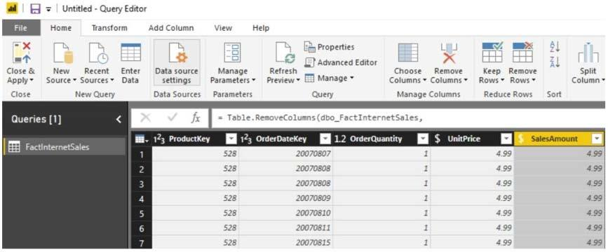

You plan to create a bar chart showing the count of sales by year that have a SalesAmount greater than $1,000.  
You need to create a measure that will be used in the bar chart.

Complete the DAX.

Measure = ________(_________(‘FactInternetSales’, ‘FactInternetSales’[SalesAmount] > 1000))

1. CALCULATE, COUNTX
2. COUNTROWS, FILTER
3. COUNTX, FILTER
4. CALCULATE, COUNT

Q-124 From the Home tab in Power BI Desktop, you click Enter Data and create a table named Sales that contains the following data.  
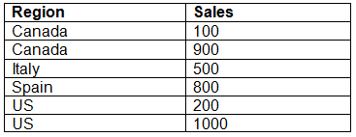  
You add Region and Sales to visualization and the visualization displays the following data.  
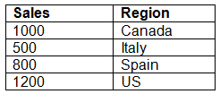  
What causes the visualization to display four rows of data instead of six?

1. Data Category of Region
2. Data type of Sales
3. Default Summarization on Sales
4. Default Summarization on Region

Q-125 You need to create a custom visualization for Power BI.  
What should you install first?

1. jQuery
2. Node.js
3. Microsft Azure Powershell
4. Microsoft.NET

Q-126 You have the following two tables:  
✑ Subscriber (SubscriberID, EnrollmentDate, ServicePlan)  
✑ Date (Date, Month, Week, Year)  
There is a relationship between Subscriber[EnrollmentDate] and Date [Date].  
You plan to create a KPI for the number of subscribers enrolled in the current year.  
You need to create a goal that is five percent more than the number of subscribers enrolled during the previous calendar year.

Complete the DAX

________________(_________________(‘Subscriber’[SubscriberID]),  
________________(‘Date’[Date]))*1.05

1. CALCULATE, SUMX, PARALLELPERIOD
2. CALCULATE, SUMX, TOTALYTD
3. CALCULATE, COUNT, PREVIOUSYEAR
4. CALCULATE, SUMX, DATESYTD

Q-127 You are creating a report in Power BI Desktop that has two visualizations on a page as shown—

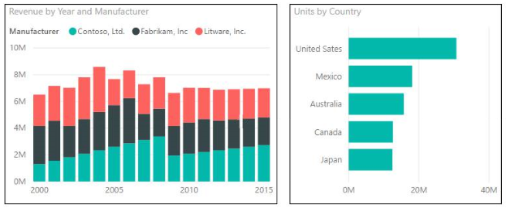

You need to ensure that when you click the bar of a country, only the values for that country are shown on the Revenue by Year and Manufacturer chart.

1)  Click the Revenue by Year and Manufacturer chart. On the Format tab, click Edit Interactions. On the Units by Country chart, click Filter.

2)  Click the Revenue by Year and Manufacturer chart. On the Format tab, click Edit Interactions. On the Units by Country chart, click Highlight.

3)  Click the Units by Country chart. On the Format tab, click Edit Interactions. On the Revenue by Year and Manufacturer chart, click Filter.

4)  Click the Units by Country chart. On the Format tab, click Edit Interactions. On the Revenue by Year and Manufacturer chart, click Highlight.

Q-128 Consider this SQL data

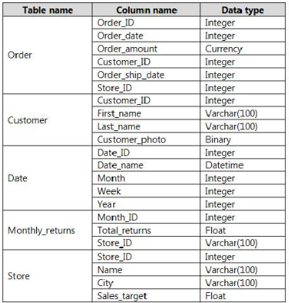

The Order table contains more than one million rows.  
The Store table has a relationship to the Monthly_returns table on the Store_ID column. This is the only relationship between the tables.  
You plan to use Power BI Desktop to create an analytics solution for the data but you need to import only a sample of the data from the Order table.

What do you do?

1. From Query Editor, create a custom column that uses a custom column formula.
2. From Query Editor, add a SELECT statement that uses a WHERE clause to the source definition.
3. In the Power BI model, create a calculated table.
4. From Query Editor, filter the table by Order_date.

Q-129 Consider the previous table only

The Store table has a relationship to the Monthly_returns table on the Store_ID column. This is the only relationship between the tables. You plan to create a chart that displays total Order[Order_amount] by Store[Name].

1) Create a relationship between the Order table and the Store table.

2) To the Order table, add a measure that uses the COUNTA('Order'[Order_ID]) DAX formula.

3) To the Order table, add a measure that uses the COUNT('Order'[Order_amount]) DAX formula.

4) None

Q-130 Ouput of SEARCH(“n”,”printer”) is-

1. True
2. False
3. 4
4. 3

Q-131 You plan to embed Visualizations to a website.

Which one can you Embed?

* Visual 1 : Uses RLS
* Visual 2 : Uses a dataset stored in MS one-drive for business
* Visual 3 : Uses a custom visual
* Visual 4 : Uses a dataset from SSAS (on premise)

Q-132 You have a workspace that contains 10 dashboards. A dashboard named Sales Data displays data from two datasets. You discover that users are unable to find data on the dashboard by using natural language queries.  
You need to ensure that the users can find data by using natural language queries.  
What should you do?

1. From the settings of the workspace, modify the Language Settings.
2. From the Sales Data dashboard, set the dashboard as a Favorite.
3. From the properties of the datasets, modify the Q&A and Cortana settings.
4. From the properties of the dashboard, modify the Q&A settings.

Q-133 Does Q&A work for Multi-Dimensional data?

1. Yes
2. No

Q-134 You manage a Power BI model that has two tables named Sales and Product.  
You need to ensure that a sales team can view only data that has a CountryRegionName (in sales table) value of Unites States and a ProductCategory (in product table) value of Clothing.  
What should you do from Power BI Desktop?

1. Add the following filters to a report. CountryRegionName is United States ProductCategory is Clothing
2. From Power BI Desktop, create a new role that has the following filters. [CountryRegionName] = "United States" [ProductCategory] = "Clothing"
3. Add the following filters in Query Editor. CountryRegionName is United States ProductCategory is Clothing
4. From Power BI Desktop, create a new role that has the following filter. [CountryRegionName] = "United States" && [ProductCategory] = "Clothing"

Q-135 You have a table named Sales. Sales contains the data shown in the following table.

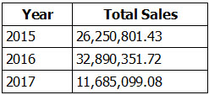

You have the following measure.  
Total Sales This Year = SUM([Total Sales])  
You plan to create a KPI to compare the current yearly sales to the previous year as shown in the exhibit. (Click the Exhibit button.)



You need to create the measure for the goal.  
How should you complete the DAX formula?

_______________([Total Sales This Year], ________________(‘Date’[Date],-1,YEAR) )

1. CALCULATE, SAMEPERIODLASTYEAR
2. CALCULATE, DATEADD
3. CALCULATE, PREVIOUSYEAR
4. SUMX, PREVIOUSYEAR

Q-136 You are creating a report in Power BI Desktop.  
You have the following tables.

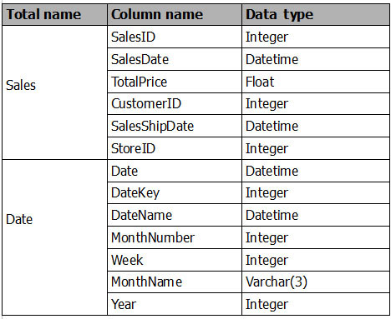

Date[Date] is in the mm/dd/yyyy format. Date[DateKey] is in the ddmmyyyy format. Date[MonthNumber] is in the mm format. Date[MonthName] is in the mmm format.  
You create the report shown in the exhibit. (Click the Exhibit button.)

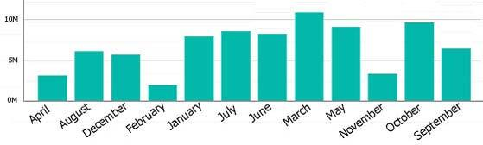

You need to ensure that the months appear in the order of the calendar.  
How should you sort the MonthName column?

1. By MonthNumber
2. Ascending
3. Descending
4. By DateKey

Q-137 You are creating a report in Power BI Desktop.  
You are consuming the following tables.

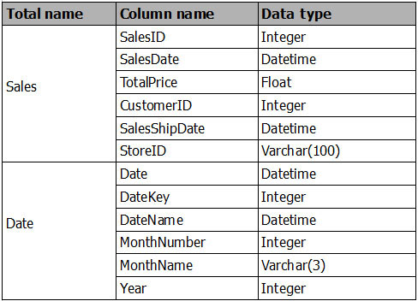

You have a new table named Fiscal that has the same schema as the Date table, but contains the fiscal dates of your company.  
You need to create a report that displays the total sales by fiscal month and calendar month.  
What should you do?

1. Union Fiscal and Date as one table.
2. Add Fiscal to the model and create a one-to-many relationship by using Date[Year] and Fiscal[Year].
3. Add Fiscal to the model and create a one-to-one relationship by using Date[Year] and Fiscal[Year].
4. Merge Fiscal into the Date table.

Q-138 What type of connection doesn’t support any kind of transformations on data?

1. Import data connection
2. Direct Query connection
3. Live connection
4. None

Q-139 You need to filter out totals from target figures. Which function does that?

* 1. Table.Filter
  2. CALCULATETABLE
  3. Table.SelectRows
  4. Table.FilterRows

Q-140 Difference between & and && in DAX?

1. & checks whether one expression is false and returns false and && checks if both expressions are true then returns true
2. & checks if one expression is true and returns true and && checks if both expressions are true then returns true
3. & is used to concatenate the strings and && checks if both expressions are true then returns true
4. None

Q-141 Data has been scraped from a table on a popular retirement website. However, the Health care quality column's scores were not automatically transformed from text to numbers when Query Editor loaded the table. You thus right-clicked the column header, and selected Change Type > Whole Number to change them.  
Unfortunately, the, Health care quality column contains a few ties in states' rankings, which was noted on the website by the word (tie) after their numbers. Query Editor thus reports a few errors.  
What is the consequence of using the Remove Errors option (ribbon or the right-click menu option) to resolve this?

1. Removes the applied steps that has errors
2. Removes the error warnings but keeps all data intact
3. Blanks the cell values that have errors
4. Removes any rows with errors

Q-142 When you enable Snap objects to grid, all visuals on the Power BI Desktop canvas that you move (or resize) are automatically aligned to the nearest grid axis, making it much easier to ensure two or more visuals align to the same horizontal or vertical location or size.  
  
You can also manage the overlap of each element on the design surface, often referred to as?

1. Vertical Stacking
2. Stack-Order
3. A-order
4. Z-order

Q-143 A retail analysis dashboard contains a small collection of datasets including Sales, Items and Stores. You have dragged the Category field from the Item dataset onto the report canvas. You now want to give users the option to select one, many or all Categories to filter the visuals on the report.  
Which element should you pick from the visualizations pane?

1. Slicer
2. Multi-row card
3. Funnel
4. Card

Q-144 As part of a large HR project you are working with a dataset of company employees, both past and present. The data includes columns for EthnicGroup, PayTypeID, HireDate (the date they started work), TermDate (the date they left) and several other columns. You want to create a new Calculated Column that determines if the person was a bad hire based on a set of rules. If they were a bad hire then the result is 1, otherwise the Calculated Column displays a zero.  
The bad hire rule is:  
BadHire = If the person stayed at the company less than 61 days  
Example: If a person joined the company on 27th June 2013 and left on 21st August 2013, then they would be a bad hire.  
Which DAX expression would you use for this Calculated Column?

1. IF(OR((([HireDate]-[TermDate])) >= 61,ISBLANK([TermDate])),0,1)
2. IF(((([HireDate]-[TermDate])*-1) < 61),1,0)
3. IF((([TermDate]-[HireDate])*-1) >= 61,0,1)
4. None

(Reason: For this expression we must use a combination of IF, OR and ISBLANK. If we forget to use ISBLANK then the difference between a date and a blank date is always 0, causing problems with the numeric comparison and potentially always showing BadHire as 1. Remember some employees won’t have left the company and hence have no TermDate value.

Q-145 You’re creating a fancy little dashboard using Power BI Service. The dashboard shows the accumulative increase in the global population over the last several decades. The dashboard will contain an introductory YouTube video that you have uploaded to the YouTube website. After uploading the video you copy the embed HTML code and paste it into your dashboard.  
Unfortunately the video is fixed to 768 pixels wide and you would like it to expand to fit the tile size. What should you do?

1. Remove the allowfullscreen parameter from the code
2. Change the iFrame width & Height attributes to 100%
3. Add an extra outer DIV with a style width:auto and height:auto value
4. Videos are fixed size and can’t expand to fit tiles

Q-146 Many data modeling and data transformations are available when using DirectQuery, though with some limitations. Which of the following is NOT a limitation of using DirectQuery?

1. All tables must come from a single Database
2. There is a 1 million row limit for returning data
3. Relationship filtering is limited to a single direction, rather than both directions
4. 1 GB dataset limitation

Q-147 When you share with people outside your organization, they get an email with a link to the shared dashboard. They need a Power BI Pro license, and they have to sign in to Power BI to see the dashboard.  
After they sign in, they see the shared dashboard in its own browser window without the left navigation pane, not in their usual Power BI portal. They have to bookmark the link to access this dashboard in the future.  
Which of the following statements is ‘FALSE’ when sharing visualizations outside of your organisation?

1. They can't edit any content in this dashboard or report
2. They can change any filters/slicers available on the reports connected to the dashboard and save their changes
3. People outside your organization can't see any data if role- or row-level security is implemented on on-premises Analysis Services tabular models
4. Only your direct recipients can see the shared dashboard. For example, if you sent the email to [Amit@inueron.ai](mailto:Amit@inueron.ai) , only Amit can see the dashboard

(Remember : They can use slicers but not save their changes)

Q-148 Some of the most powerful data analysis solutions in Power BI Desktop can be created by using measures. Measures help us by performing calculations on our data as we interact with our reports. Understanding aggregations is fundamental to understanding measures, because every measure will perform some type of aggregation.  
  
Which of the below is TRUE regarding measures in Power BI?

1. You can reference another measure in a DAX expression by just typing an opening bracket ([)
2. Every time you interact with your report, you are changing the context in which a measure calculates and displays its results
3. You can create a new measure by clicking on the New Measure button in the ribbon on Power BI Desktop’s Home tab
4. All of the above

Q-149 You can easily add a new custom column of data to your Power BI Desktop model. You can create and rename your custom column using easy buttons to create M formulas that define your custom column.  
How would you add a custom column?

1. Home🡪Query Editor🡪Home🡪DataSource settings
2. Home🡪External Data🡪Enter Data
3. Home🡪Relationships🡪Manage Relationships
4. Home🡪Query Editor🡪File🡪Add Column

Q-150 Having created a new blank model you want to load in data from a SQL Server database which is hosted on the same PC as the Power BI Desktop application. You click the Get Date ribbon option and select SQL Server from the drop down list.  
What should you enter in the Server textbox?

1. Local
2. [blank]
3. Host
4. Localhost

Q-151 The following table contains a Parent-Child hierarchy on the columns: Employee Key and Parent Employee Key. From the table you can see that employee 112 has no parent defined, employee 14 has employee 112 as manager (ParentEmployeeKey), employee 3 has employee 14 as manager and employees 11, 13, and 162 have employee 3 as manager. The above helps to understand that employee 112 has no manager above her/him and she/he is the top manager for all employees.

|  |  |  |  |
| --- | --- | --- | --- |
| **Employee Key** |  |  | **Parent Employee Key** |
| 112 |  |  |  |
| 14 |  |  | 112 |
| 3 |  |  | 14 |
| 11 |  |  | 3 |
| 13 |  |  | 3 |
| 162 |  |  | 3 |
| 117 |  |  | 162 |
| 221 |  |  | 162 |
| 81 |  |  | 162 |

The PATHLENGTH Function (DAX) returns the number of levels in a given PATH(), starting at current level until the oldest or top most parent level.  
What would be the PATHLENGTH value for the third row (values 3 and 14)?

1. 2
2. 4
3. 3
4. 1

(REASON: 3 as path will be🡪 112|14|3)

Q-152 A complicated dashboard for the finance department requires you to combine three separate text fields together to form a concatenation of Country, Region and City. Which DAX expression below would successfully concatenate the three fields together into a single string result?

1. CONCATENATE( [Country], “, “, [Region], “, “, [City] )
2. CONCATENATEX( [Country], “, “, [Region], “, “, [City] )
3. [Country] + “, “ + [Region] + ", " + [City]
4. [Country] & “, “ & [Region] & ", " & [City]

Q-153 When you import multiple tables, chances are you’re going to do some analysis using data from all those tables. Relationships between those tables are necessary in order to accurately calculate results and display the correct information in your reports.  
Imagine an example of a model that has a Sales actuals table with a lookup table for department and also a budget sales table that records target budget for each department. The department table is connected to both the sales and the budget table.

Which kind of Cross Filter Direction would you use in this example?

1. Single
2. Both

Q-154 If you want to combine data from multiple sources into a single model, for example, to join some data from a corporate SQL Server database with some local data maintained in an Excel file. Is DirectQuery a good choice for this scenario rather than Import?

1. Yes
2. No

Q-155 You have loaded data from a database table which contains a list of filenames that have been processed by an internal team. One particular column called filename contains the name of each file processed e.g. enrollment.batch11.xml  
Which Transform function would you use to dissect the filename values into two separate columns, one for the filename and the other for the file extension e.g. xml

1. Extract - Text before delimiter
2. Split Column - Split at Each occurrence of the delimiter
3. Extract - Text after delimiter
4. Split Column - Split at Right-most delimiter

Q-156 Reports are often confused with dashboards since they too are canvases filled with visualizations. But there are some major differences. Which one allows you to filter, highlight, and slice, and also see dataset tables and fields and values?

1. Report
2. Dashboards
3. Neither
4. Both

Q-157 The Union DAX command creates a union (join) table from a pair of tables but which statement below is FALSE regarding Union?

1. The two tables must have the same number of columns
2. The column names in the return table will match the column names in table_expression1
3. Columns are combined by position in their respective tables
4. Duplicate rows are removed

Q-158 Which type of visualisation would you choose if you wanted to show relationships between 3 numerical values and turn the horizontal axis into a logarithmic scale? The worksheet data would include grouped sets of values and you wanted to show patterns in large sets of data, for example by showing linear or non-linear trends, clusters, and outliers?

1. Scatter plot
2. Tree Map
3. Bubble Chart
4. Pie Chart

Q-159 Output of DAX 🡪 IF(ISLOGICAL(“true”), "Is Boolean type or Logical", "Is different type") is—

1. Is Boolean type or Logical
2. Is different type

Q-160 When you share a dashboard with tiles that link to reports, those reports are also shared at the same time. But what if you want to share just a report? Just send the report page URL to your colleagues. As long as they have Power BI Pro licenses, are members of the same distribution group, in the same email domain as you, or have at least one dashboard that links to that same report (the dashboard has tiles that were pinned from that report), they'll be able to open the report.  
  
You want to share a report that is prefiltered on the Store Territory with a value of UP. What should you add to the end of the report URL before you share it?

1. ?filter=Store/Territory = UP
2. ?filter=Store/Territory eq UP
3. ?filter=Store/Territory == UP
4. ?filter=Store[Territory] eq UP

Q-161 You want to write a DAX expression that checks if the product code column contains the value “ex”. Which DAX function below is the right one to use?

1. FIND(“ex”,[ProductCode])
2. SEARCH(“ex”,[ProductCode])
3. CONTAINS(tablename,[ProductCode],”ex”)
4. NONE

Q-162 With Power BI Publish to web, you can easily embed interactive Power BI visualizations online, such as in blog posts, websites, through emails or social media, on any device.  
You have published a visualization but unfortunately changes to the underlying data are not immediately visible to users. What might be wrong?

1. We must refresh the data manually to the web
2. It takes upto an hour for the data to refresh
3. It’s not possible to update/refresh the data after publishing on the web, visuals are static
4. User is restricted by RLS

Q-163 The DAX FORMAT function is used to convert a value to text according to the specified format that you provide as the second argument to the function. Which DAX expression below would format the number so that it’s displayed as 40.00%?

1. FORMAT(0.4,”Percent”)
2. FORMAT(0.4,”p”)
3. FORMAT(0.4,”%”)
4. FORMAT(40,”Percent”)

Q-164 You have noticed a large spike in your gross-margin between July and august 2020.You want to find out the reason for this though you are not sure what to analyse.

What Feature can you use here?

1. Use Q&A visual and ask ‘Why have sales increased from July to august 2020?’
2. Right click on the month’s value, select analyse and choose ‘Explain the Increase’
3. Use Azure ML visual and drag in the gross margin field to the ‘Explain’ bucket.
4. Call DV (your data analyst)

Q-165 You drag the field into the ‘Explain by’ bucket of the decomposition tree visual and they don’t appear as nodes/leaves in the visual. Why?

1. The decomposition tree is a preview visual – once the feature is enabled (under file 🡪 options) the field will appear in the visual
2. You cannot enter attributes/dimensions in the ‘Explain by’ bucket – it has to be other measures
3. The fields that are entered into ‘Explain by’ are possible splits that you (or an end user) can then choose from in terms of how to analyse the metric using the visual.
4. The field that have been entered are from dimension table which have no relationship with the metric being analysed

Q-166 What is the difference between groups and bins in Power BI?

1. You would use groups with text values(Categories/attributes) and bins with numerical values.
2. Groups work with dax whereas bins use M
3. Groups and bins are identical.
4. Groups are grouping of text values and bin is actually a dust-bin for power bi which contains deleted values of data.

Q-167 You create a Bar Chart visual showing Quarter wise sales for year 2020.

(Assume sales on y-axis and bars of Q1,Q2,Q3,Q4 ON xaxis)

You want a separate color for Q1 bar, how do you achieve it?

1. Conditional Formatting
2. Groups
3. Calculated Column
4. Calculated Measure

Q-168 Tree map belong to which Visual Segment?

1. Comparison
2. Composition
3. Distribution
4. Relation

Q-169 KPI belongs to which visual segment?

1. Comparison
2. Composition
3. Distribution
4. Relation

Q-170 You have a line chart , with

Sales on Y-axis and dates on X-axis. The visual shows Jan 2020,Jul 2020,… on X axis instead of Months (like Jan,Feb,Mar….)

What do you do?

1. Increase the minimum category width of the X-axis in the formatting pane
2. Increase the ‘Maximum Size’ of the X-axis in the formatting pane
3. Change the X-axis from type ‘Continuous’ to type ‘Categorical’
4. Reduce the text size on X-axis

SUBJECTIVE QUESTIONS

Q-1 Describe all types of Visual segments with examples

1. Composition segment – Pie chart, Tree map

The Composition chart tells us about the composition of a quantity. 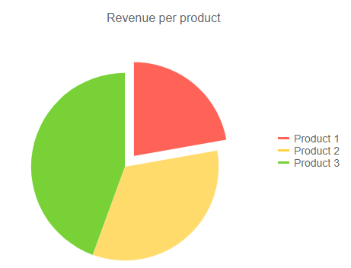

Like this Pie chart shows us how different Products compose the revenue.

1. Distribution segment – Histogram,KDE Plots

The Distribution chart tells us about the approximate representation of distribution of numerical data. (Univariate data). Let’s look at this Histogram showing the distribution of response time (in hrs) of a medicine. Distribution is bi-modal. This type of distribution helps us find outliers and skewness of a variable.

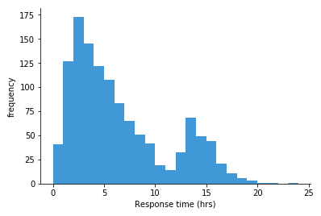

1. Trend Segment – Line charts

The charts in this segment tells us about the change of a variable over time.

These are widely used in Time-Series analysis.

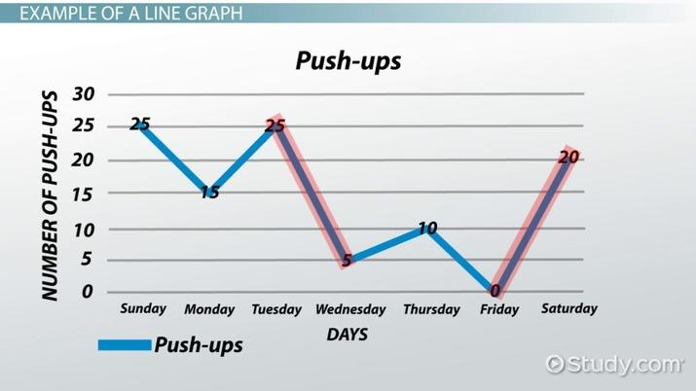

Just like this line graph showing us the Push-ups trend of a person over the week.

1. Maps – ArcGis graph, Chloropleth map.

These are just normal Geographical graphs used for variables containing actual locations. These graphs are helpful as they are more interactive than for example a Bar graph or slicer when analyzing a quantity by region. **Note**: Using these graphs in Power Bi will require an Internet connection.

1. Relation – ScatterPlot , Bubble Chart

These charts tells us the relation between two/three variables. Whether the are positively related(one increases with other & one decreases with other) or negatively related(one decreases while the other increases and vice-versa) or

Not related (no relation, both are independent). We can find out a lot about distributions (Bi-Variate), outliers and discover clusters if any exist.

1. Comparison – Bar graph, Funnel charts etc

These are extremely simple graphs which everyone must have seen atleast ones.

These are helpful and widely used for comparing values because of their high interpretability. For example – If we want to compare Top N customers by the amount they spend on our products.

These are all, now it’s does mean a chart can’t be used to display more than one segment. For example 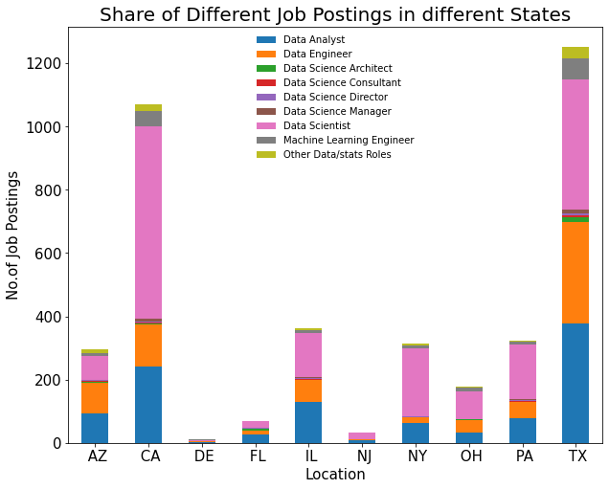

This stacked bar chart not only shows us the comparison of Locations by Number of job postings but also tells us about composition of different job types inside the bars.

Q-2 Difference between a report and a Dashboard

A report consists of multiple pages whereas Dashboard consists of Just one. Report is like a big collection of visuals from multiple tables which can then be pinned on the dashboards for an overview or a summary.

Q-3 What are Many-to-Many relationships?

Many-to-many relationships involve bridge tables that reflect the combination of two elements. For example, a table may list managers to employees or doctors to patients*.* Here one manager can manage multiple employees and one employee can also have multiple managers so therefore a many-to-many relationship.

Q-4 DirectQuery vs Import?

Direct Query should be used for large datasets/big data as importing that data onto Power Bi model can slow it down and reduce it’s performance drastically. But DirectQuery doesn’t support many DAX functions and some transformations so we should be careful about that.

On the other hand Importing the data is good only for small-to-medium datasets but is extremely useful for Data Cleaning and transformations and we have a lot DAX function for analysis.

Q-5 What are advantages of using Variables?

The advantages are-

1. ReUsability : By declaring and evaluating a variable, the variable can be reused multiple times in a DAX expression, thus avoiding additional queries of the source database.
2. Interpretability : Variables can make DAX expressions more intuitive/logical to interpret.
3. Scope-of-Variables : Variables are only scoped to their measure or query, they cannot be shared among measures, queries or be defined at the model level.

Q-6 Can SQL be used in Power Query Editor?

Yes, a SQL statement can be defined as the source of a Power Query/M function for additional processing/logic. This would be a good practice to ensure that an efficient database query is passed to the source and avoid unnecessary processing and complexity by the client machine and M function. It is also used in Query Folding for optimization.

Q-7 Define Power BI’s Q&A?

Power BI Q&A is a natural language tool which helps in querying your data and get the results you need from it. You do this by typing into a dialog box on your Dashboard, which the engine instantaneously generates an answer from the data. Q&A interprets your questions and shows you a restated query of what it is looking from your data. Q&A was developed by Server and Tools, Microsoft Research and the Bing teams to give you a complete feeling of truly exploring your data.

Q-8 Define Data Security in Power Bi?

Data Security is nothing but data viewing restrictions on people.

We use RLS or Row-Level-Security for this.

1. Static security is creating separate roles in PBI Desktop and assigning them manually in Power BI service
2. Dynamic Security involves the use functions like USERNAME and USERPRINCIPALNAME in security role definitions. These are DAX Functions which can provide access to the people who are logged in.

Q-9 Consider functions like SUM,SUMX and AVERAGE,AVERAGEX. What is this X implifying?

The X tells us that the function works in a row context. Absence of this X tells that the agg func works in a column context. Also, we can enter an expression to be evaluated on which the aggregation will be performed, simple SUM & AVERAGE don’t provide it and just return a scalar value after aggregating the whole column.

Q-10 Why use Calculated measure over Calculated column whenever possible?

Calculated Columns are DAX expressions that are computed during the model’s processing/refresh process for each row of the given column and can be used like any other column in the model. Calculated columns are not compressed and thus consume more memory and result in reduced query performance. They can also reduce processing/refresh performance if applied on large fact tables and can make a model more difficult to maintain/support given that the calculated column is not present in the source system.

Calculated measures are DAX expressions which are calculated on the fly, that is, calculated when needed. The greatest advantage is that measure value is not stored in the memory. The measure will not consume Memory or RAM at all but it is calculated by the CPU.(If we don’t want to get all technical just understand that instead of asking CPU to ask RAM for information we are directly asking CPU for information) . Measures are not pre-calculated either, they are calculated when needed.

Q-11 Explain different types of filters in Power Bi? Is RLS a filter?

Power BI provides variety of option to filter report, data and visualization. The following are the list of Filter types--

**Visual-level Filters:** These filters work on only an individual visualization, reducing the amount of data that the visualization can see. Moreover, visual-level filters can filter both data and calculations.

**Page-level Filters**: These filters work at the report-page level. Different pages in the same report can have different page-level filters.

**Report-level Filters**: There filters work on the entire report, filtering all pages and visualizations included in the report.

There is also a Slicer which acts as Page-level-filter in PBI Reports. But this will be a visual and will be visible in the main report

No RLS is not a filter but is associated with data security.

Q-12 What is Power BI Embedded?

PowerBI embedded is an Azure-based cloud Service which enabled Web developers to create and integrate PowerBI reports. Users/Developers can create their reports using PowerBI desktop, without the need to write any code. Then, the PowerBI desktop report can be published to a PowerBI embedded workspace and consumed by end users.

Q-13 State the difference between COUNT and COUNTD Function?

COUNT Function will count all values except NULL/BLANK values whereas COUNTD will count all DISTINCT values except for NULL/BLANK values.

Q-14 In DAX functions like VAR.S & VAR.P, what are the P&S implifying?

The P implifies that the value (variance) is being calculated for the whole population whereas S implifies that the value is being calculated for a sample.

Q-15 What is equivalent of Append Queries in DAX? State Syntax also

UNION function can be used in DAX to achieve the same results as append queries.

Syntax- new table = UNION(table1,table2)

Q-16 Explain the types of Joins in Power Bi Query editor?

We have Six types of Joins in Power BI which we use it in Power Query Editor:

1. Inner Join Left Outer Join Right Outer Join Full Outer Join Left Anti Right Anti Inner Join: If we want only the matching records from both the tables then will use Inner join/Simple join
2. Left Outer Join: If we want all the records from left table and only matching records from right table then will use left Outer join/left join.
3. Right Outer Join: If we want to display all the records from right table and only matching records from left table then will Right Outer join/Right Join.
4. Full Outer Join: If we want display all the records from both the tables then will use Full Outer Join
5. Left Anti: Displays only the mismatched records from Left Table
6. Right Anti: Displays only the mismatched records from the Right Table.

Q-17 What are the types of tables in Power Bi?

Fact Tables:

The central table in a star schema of a data warehouse is a fact table that stores quantitative information for analysis, which is not normalized in most cases. Aggregations are performed on the columns of this table and it is a good practice to place it below the Dimension table in the Data Model view

Dimension Tables:

It is a table in the star schema which helps you to store attributes and dimensions which describe objects that are stored in a fact table. It is a good practice to place it above the fact tables to give a clear view.

Q-18 How to represent different levels of hierarchy of data in one singe visualization?

1. Create a hierarchy by grouping the required data from the data tab and pull that into Axis Tab and Enable drill down option by clicking on down arrow on the chart.
2. Pull all the hierarchical columns separately in to the axis pane in the order of their hierarchy and enable the drill down action by clicking on down arrow on the chart.

Q-19 Name some important charts and state why they are important for you?

Sample Answer : The three types of charts I use most often are Line charts, Histograms, bar charts. In my role as BI analyst, Line charts have helped me display where a specific trend is headed in the future, which, in turn, makes planning easier. Bar charts, on the other hand, can show clearly which products are most popular among customers or display the number of unique visitors on a landing page based on various criteria. Histograms, as they help me to see what type of distribution are we dealing with for the analysis and identify & deal with Outliers.

Q-20 What is Bookmark? How do you create it?

Bookmark in Power BI helps you to capture the configured view of a report page in a specific time. This includes filter and state of visual which can use a short cut to come back to the report that you can add as a bookmark.

To create it ,

While on a Report Page🡪 Click on View Tab 🡪 Click on Bookmarks 🡪Click on Add (if the current page that you are on is the one you wanna create a bookmark for, think of it like a screenshot)

Q-21 Give an example of a visual from Power BI which serves as a Cross-Table? Is table visual right?

Matrix visual from Visualization pane in Power BI Desktop can serve as a Cross-Table and not normal Table visual as Cross-Tables can be multi-dimensional and expanding and collapsing components of column is available in a Matrix visual only.

Q-22 How to create Heirarchies in Power BI?

When you have set of fields that is on hierarchy Example -- Product Category and Product names, you can set up hierarchy by dragging the product name over the product category so that a new hierarchy field is created where we can drill down the data and see the detailed data. Consider you have list of countries and cities you can create hierarchy as follows in the fields pane << drag city field onto country field << the hierarchy will be created.

Q-23 What are main three fundamental tabs of Power BI Desktop?

The Report View tab where all the visuals are contained in one/multiple pages.

The Data View tab where we can view the data and do some basic formatting

The Data Model tab where we can design our table Schema and create/delete/edit relationships between tables.

Q-24 Tell all the data-types available in Power Bi?

1.Numeric(Decimal,Fixed Decimal,Whole)  
2.Text  
3.Date/Time  
4.Boolean(true/false)  
5.Binary

Q-25 Tell two ways to navigate in Reports.

1. Create Buttons and Set action to Bookmarks
2. Create Buttons and Set action to Page Navigation

Q-26 How to import/Scrape data from web using Power Bi?

Steps will be –

1. Go to get data option which is present in Hone Ribbon tab on Power BI Desktop and then select web option
2. Copy and paste the URL  in the web dialog box and then click ok.
3. After that, the connection is established to the particular URL, and the Power BI navigator dialog box shows the catalog of the tables on the page.
4. Finally, select the Results(edit) in the Navigator page and then click edit. Now, the preview of the tables will be opened in the Power BI query editor in which we can analyze and transform the data from a web page.

Q-27 Can you calculate Correlation using dax as there is no predefined function for it? Consider Table with columns Sales, Area. Find the correlation coefficient between them. Formula below--

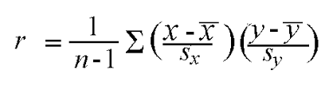

CAUTION!! This could be wrong.

Ans-

Score measure =  
var mean1 = CALCULATE(AVERAGE(Table[Sales]),ALL(Table))  
var StandardDeviation1 = CALCULATE(STDEV.P(Table[Sales]),ALL(Table))

var mean2 = CALCULATE(AVERAGE(Table[Area]),ALL(Table))  
var StandardDeviation2 = CALCULATE(STDEV.P(Table[Area]),ALL(Table))

RETURN DIVIDE((SUM(Table[Sales])-mean1)/StandardDeviation1) * (SUM(Table[Area])-mean2)/StandardDeviation2) , COUNT(Table[Sales])-1)

Notations I have taken wrt formula, x = Table[Sales],y = Table[Area], S_x & S_y = StandardDeviation1 & StandardDeviation2 , x_bar = mean1 & y_bar = mean2

Q-28 You want to create a line chart showing Quantity by the invoice date.

**Ans** - There exist an active relationship between Date Column from the Date table and delivery date column from the Sale table.

Now You notice that there is a relationship between the Date column from the Date table and the Invoice Date Key column from the Sale table, but the relationship is inactive. All other visuals in your report will be analyzing values by delivery date. How should you approach this problem? Give reason for your approach?

**Ans**- We will use a measure

Quantity by Invoice Date = CALCULATE ( SUM ( Sale[Quantity] ), USERELATIONSHIP ( ‘Date’[Date], Sale[Invoice Date Key] ) )

I wouldn’t change or delete existing relationships as other visuals in the report rely on that.

Hence using dax measure will activate relationships when needed at the query time, involves least effort

Q-29 How can you make sure that each category manager can see sales of their category only and allow the CEO to see all sales in a single report? Your solution must involve minimal effort.

**Ans-** Configure dynamic row-level security for managers involves least effort and a separate role for the CEO ensures full accessibility to him.

Creating different reports will be a very hectic task and difficult to maintain. Slicer provides no security.

Q-30 Any Difference between Histograms and Bar charts?

**Ans** – Visual difference – Histograms appear vertically stacked whereas Bars are separated (lol)

Intuitive difference – Histograms study distributions whereas Bar charts are used in making Comparison. Histograms show distribution of non-discreet variables/continuous variables (quantitative data) whereas Bar graphs show comparison of discreet variables (categorical data)

Bars can be re-ordered in Bar graphs but not in histograms.

